Assignment – 2

**Assembling the CPU**

1. Lift the Processor cover And Remove the Processor.

# WP_20180828_15_16_43_ProIMG-20180828-WA0006IMG-20180828-WA0006IMG-20180828-WA0013

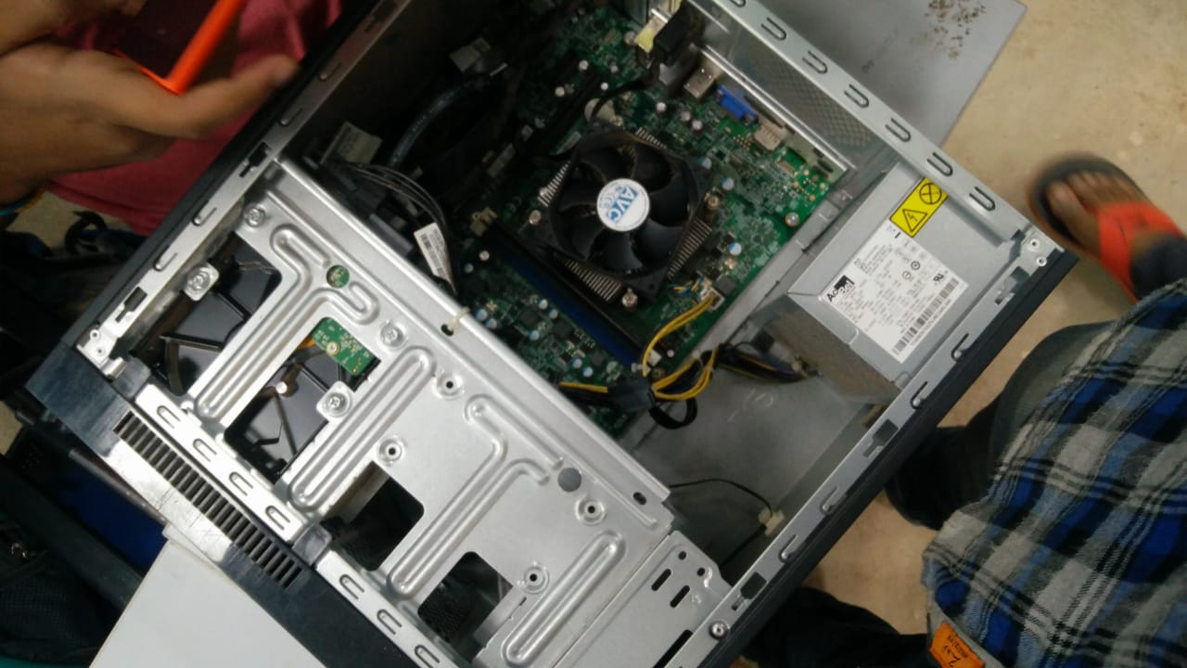

1. Remove the side Cover of the CPU Box. 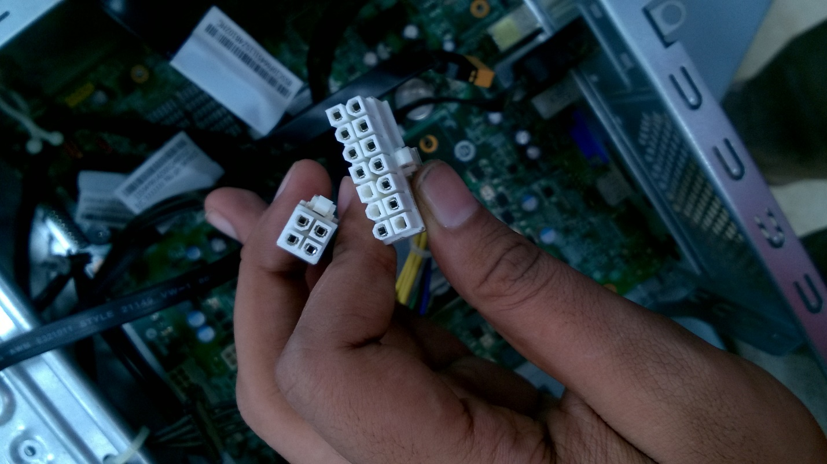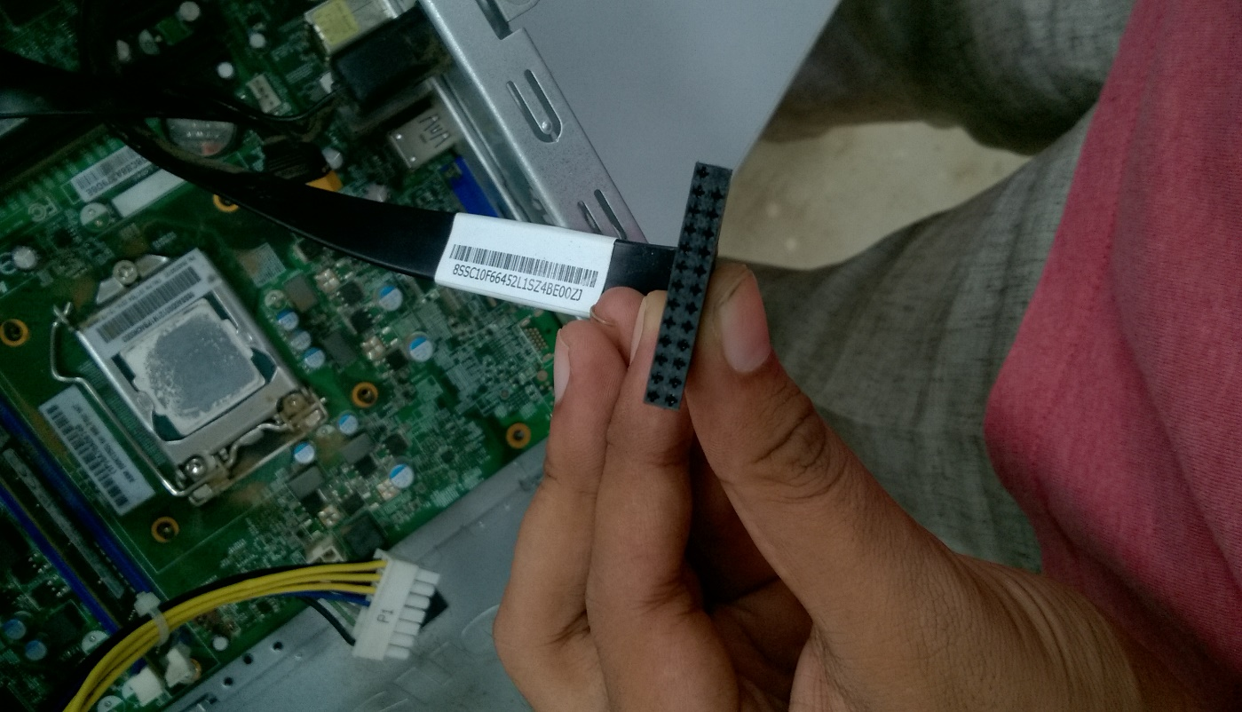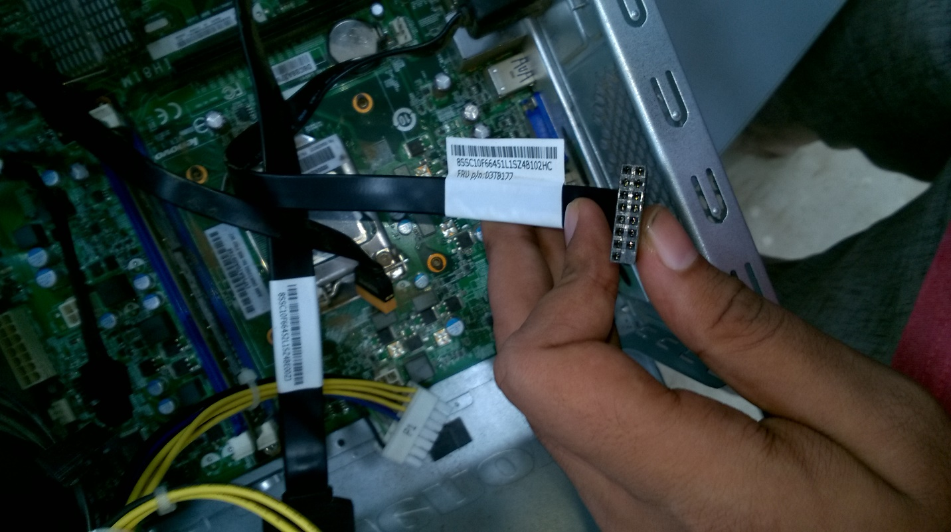
2. Unplug the SATA Cable and Power Input from the Hard Disk and Remove it from its Cabinet.

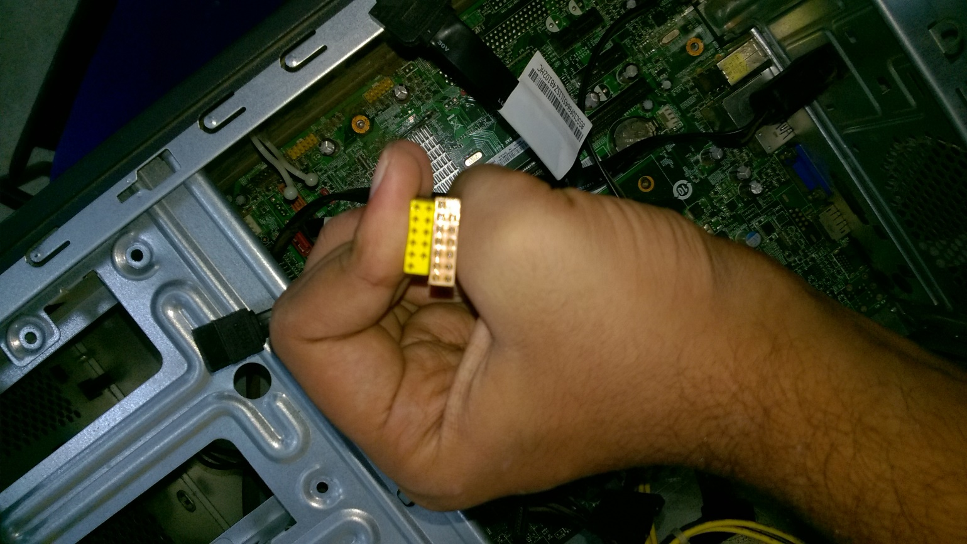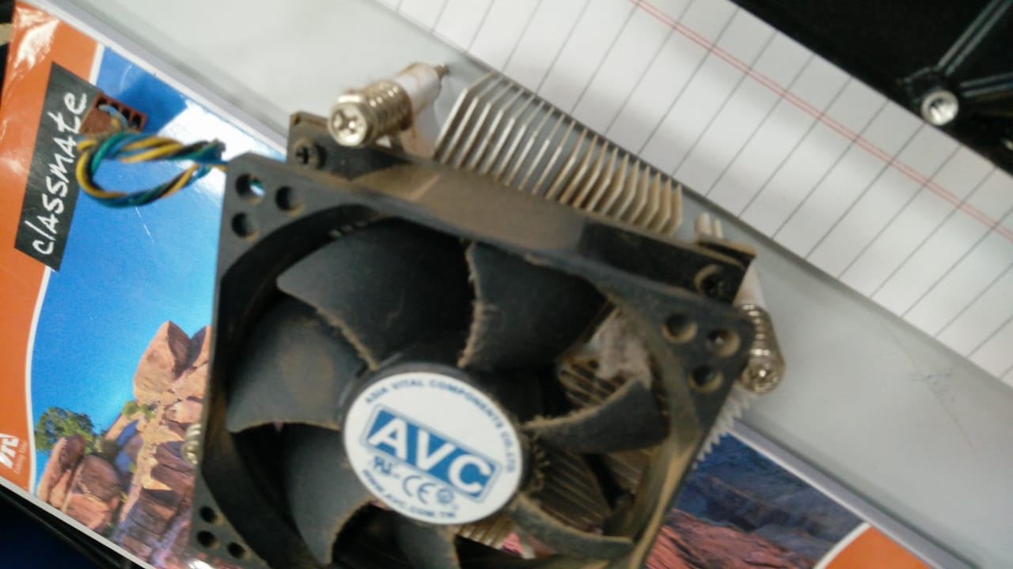 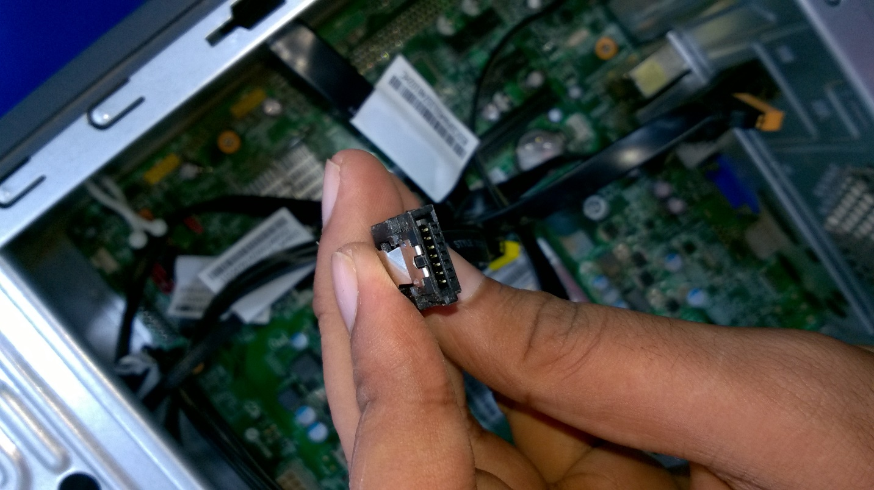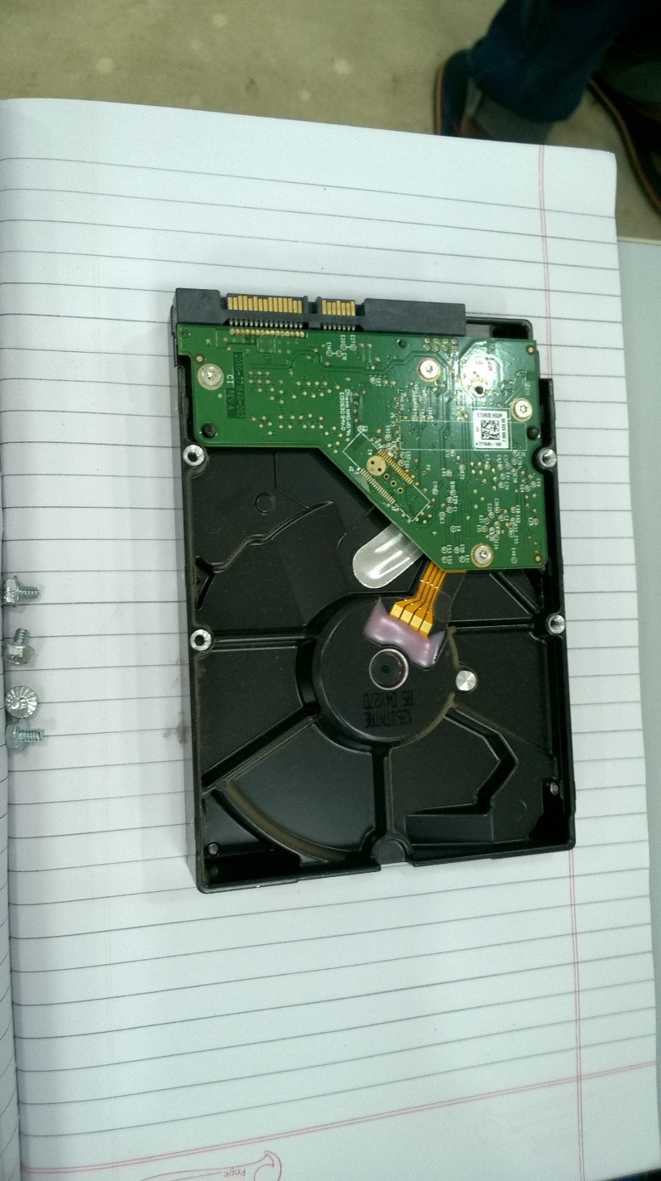



1. Remove the SMPS Box by unscrewing the four screws on the back side of the CPU Box.
2. Remove the Motherboard power Input cables.
3. Remove all Cables from the jumpers used for Gaming Port and/or Serial Ports.
4. Remove all other Cables connecting the Motherboard to CPU Box’s USB Port, Audio/Microphone Jack, LED light and Speaker.
5. Unscrew all the Screws connecting the motherboard.
6. Slowly and cautiously remove the motherboard from the CPU Box;
7. Remove the RAM from the Ram Slot and Remove the CMOS Battery.
8. Unscrew the screws of the Heat Sink and Remove the Heat Sink.

**The CPU has been disassembled.**